Tanjeet Singh

Digital Marketing Executive

Contact Information
90, Engineers Enclave, Pitam Pura, New Delhi-34

9811093387

tanjeetsingh25@gmail.com @tanjeet-singh
Technical Skills
Search Engine Optimization(SEO) - Excellent
Search Engine Marketing (SEM) - Competent Keyword Analysis and Optimization - Excellent Social Media Management Wordpress & Updating Content - Professional Strategic Planning Content Marketing Management
Competitor Analysis

Career Objective
Seeking a job in SEARCH ENGINE OPTIMIZATION, where I can contribute my knowledge creativity and professional skills and to effective solution that will help the organization to achieve the best solution in business and ultimately increase its productivity in market.

Work Summary
Team Manegement and Work on Digital Media platforms that involved all SEO related activities, plnning for new SEO strategy to increase trafficin different phases like Organic, Social Media, Paid and direct to increase visibility of web in google search engine.
Good skill of Search Engine Optimization(SEO), On-Page and Off-Page SEO work, blogging, article submission, pdf posting, classified ads, link building, social bookmarking, guest posting, etc.
Competitor analysis, site analysis, strategy planning.
Analyse website issue wiith Google Webmaster, solved the technical issue of site through webmaster..
Good understanding of Social Media Optimization(SMO), Facebook, Pinterest, Youtube, Instagram.
Improve organic performance through keyword research, multi-linked keyword, and landing page performance.

>

Work Experience
2+ Years of core experience in Digital Marketing and Media( SEO, SMO, SEM, Adwords)
SIGNATURE VISAS

Digital Marketing Executive | November 2018 - present
Key Responsibilities:
On-page and Off-page SEO activities for website
Keyword Research and Analysis based on services provided Regular track of keyword ranking
Social Media, Youtube, Website Branding

Duties and Responsibilities:
On-Page Optimization: Website Analysis, Make Website Audit Report, Keyword Research and Analysis, Meta Tags Optimization, Header Tags, Image Optimization, Page Content Optimization, XML Sitemap Creation, Robot File Creation, Site Navigation and User Interface, Webmaster, Google Analytics, Google Adword, Site Audit, Performance Report

Off-Page Optimization: Content Posting, Blog Commenting, Article Submission, Guest Posting, Classifieds Submission, Business Listing, Blog Posting and Submission, Social Bookmarking, Directory Submission, PDF Posting, PPT Posting, Video Submission.

Search Engine Marketing: Knowledge of Google Adwords, Paid Marketing on Google Adwords, Create Search and display ad campaign, Monitor ads campaign.

Social Media Marketing: Manage profiles on all Social Media sites like Facebook, Twitter, Pinterest, LinkedIn, Youtube, etc and ensure end-to-end Online Branding and Reputation Management.

Academic Background
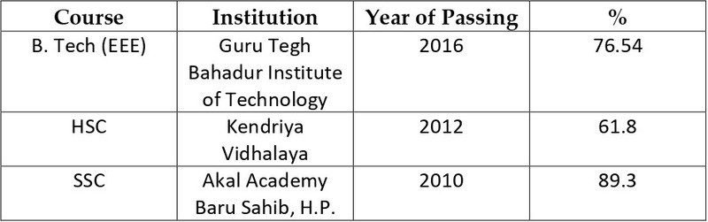
Technical Software Skills
Semrush Sendinblue Excel

Other Skills
Zoom, Google Meet, Microsoft Team

Personal Details
Date of Birth : 28 January, 1994 Language : English, Hindi, Punjabi
Interest & Activities : Music, Sports, Travelling

